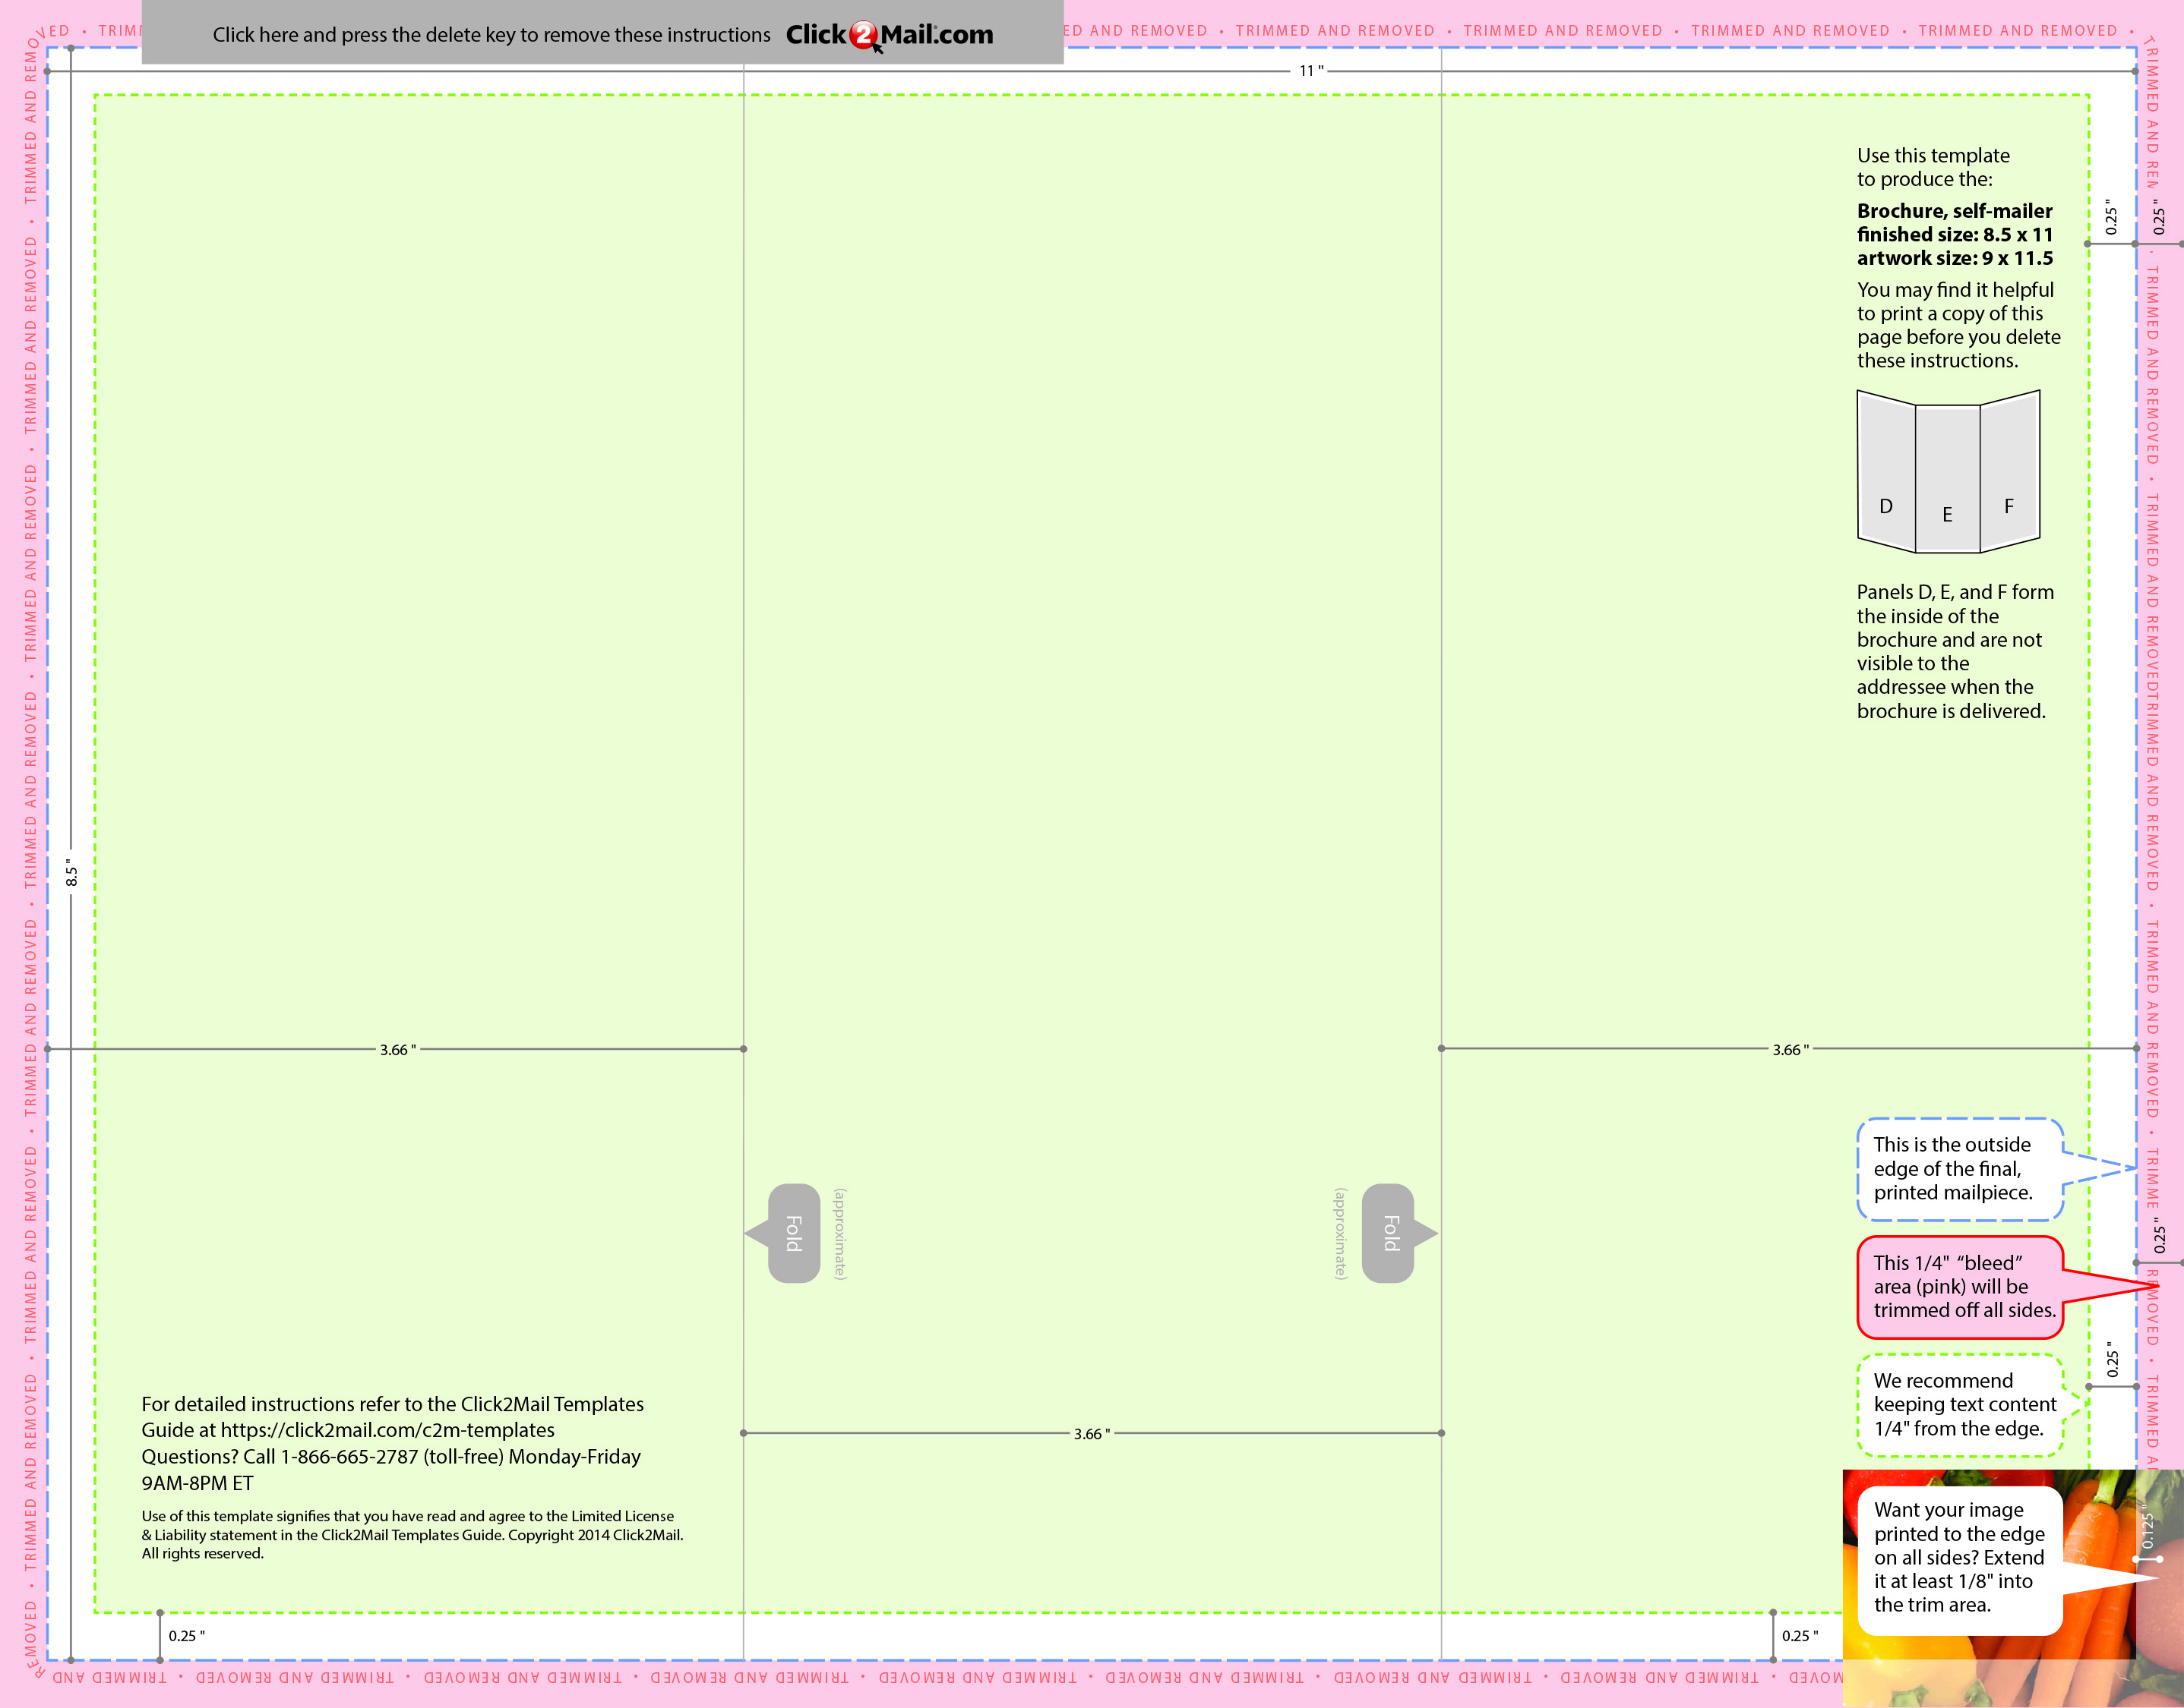

Placeholder text... Replace this placeholder text with text of your own. Use Click2Mail.com to print, finish, post, and deliver your mailpieces quickly and economically. Click2Mail.com makes it easy to design brilliant, full-color, affordable postal mail without permits, sorting, stamps, or trips to the Post Office. How does it work? We use a network of strategically located, high-quality printers to print, prep, and sort large volumes of mail daily. That network and our understanding of strict postal requiremens allows your mailpiece to receive optimal handling and delivery

Placeholder text... Replace

this placeholder text with

text of your own.

Placeholder text... Replace this placeholder text with text of your own. Use Click2Mail.com to print, finish, post, and deliver your mailpieces quickly and economically. Click2Mail.com makes it easy to design brilliant, full-color, affordable postal mail without permits, sorting, stamps, or trips to the Post Office. How does it work? We use a network of strategically located, high-quality printers to print, prep, and sort large volumes of mail daily. That network and our understanding of strict postal requiremens allows your mailpiece to receive optimal handling and delivery

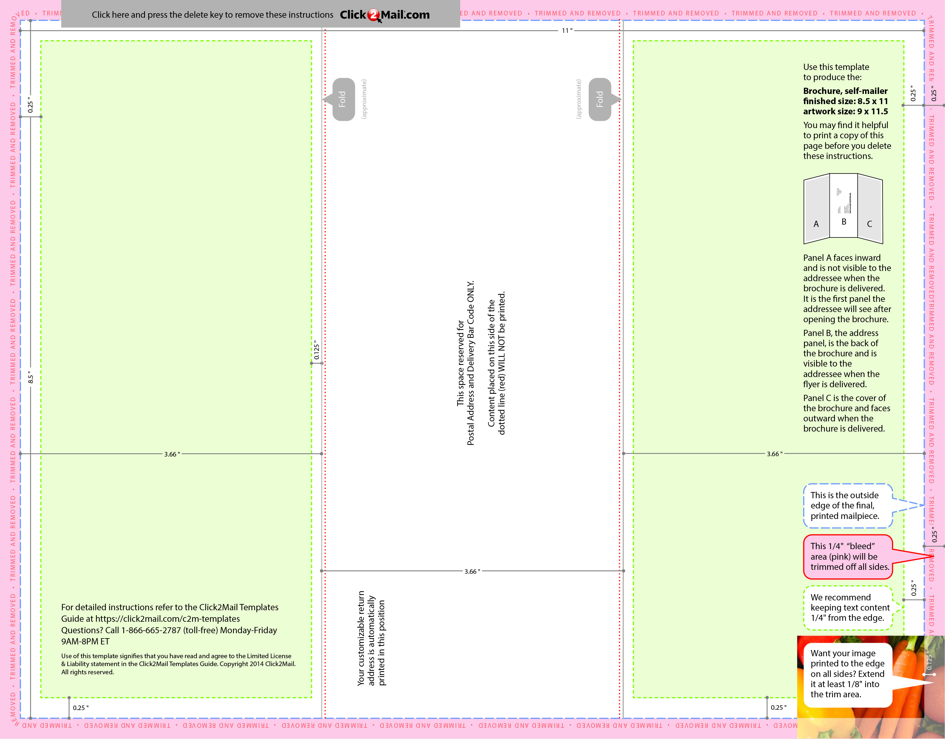

Placeholder text... Replace

this placeholder text with

text of your own.

Placeholder text... Replace this placeholder text with text of your own. Use Click2Mail.com to print, finish, post, and deliver your mailpieces quickly and economically. Click2Mail.com makes it easy to design brilliant, full-color, affordable postal mail without permits, sorting, stamps, or trips to the Post Office. How does it work? We use a network of strategically located, high-quality printers to print, prep, and sort large volumes of mail daily. That network and our understanding of strict postal requirements allows your mailpiece to

receive optimal handling and delivery. You benefit from high volume processing without

setup fees or minimum quantities.